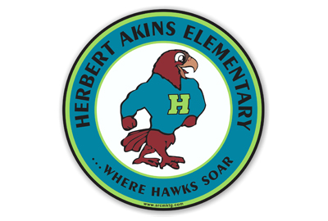

**Herbert Akins Road Elementary**

**5th Grade Supply List 2024-2025**

|  |  |  |
| --- | --- | --- |
| **Item** | **Amount Needed** | **Notes** |
| Colored Pencils | 1 pack |  |
| Highlighters | 2 packs | Packages with yellow, pink, green, and blue |
| Composition Books (not spiral) | 5 |  |
| Folders with pockets | 3 |  |
| Lined Notebook Paper | 4 packs | Wide Ruled only |
| Pencils | 3 pack | Ticonderoga preferred |
| Scissors | 1 |  |
| Glue Stick | 2 packs |  |
| 3 x 3 post-it notes | 4 packs |  |
| Pencil pouch or box | 1 |  |
| Earbuds/Headphones | 1 | Need a pair that can stay at school year-round |
| Large erasers | 3 | Pentel Hi-Polymer White Block Erasers work the best |
| Ziploc bags (Quart or Gallon)- Boys  Kleenex tissues- Girls |  |  |

|  |  |  |  |
| --- | --- | --- | --- |
| **Additional Supplies Needed by Track** | | | |
| **Track 1**   * 1 pack of lined index cards | **Track 2 - Lockamy**   * 1 homework planner:   this is a great option:  [Elementary Student Planner from Amazon](https://www.amazon.com/dp/B0CX26NYBT?ref=cm_sw_r_cso_cp_apin_dp_1S0986AFYQJ16KTG8KKE_1&ref_=cm_sw_r_cso_cp_apin_dp_1S0986AFYQJ16KTG8KKE_1&social_share=cm_sw_r_cso_cp_apin_dp_1S0986AFYQJ16KTG8KKE_1&starsLeft=1)   * Two 2-inch binders * Binder tabs * Dry Erase Markers & Clean Sock | **Track 3- Over**   * $6 for Time for Kids subscription   (Cash or Check made payable to Time for Kids)   * Glue sticks- 1 more pack | **Track 4- Joyner & Edwards**   * Pencil Cap Erasers * Glue Sticks- 3 more packs * Dry Erase Markers & Clean Sock * 1 inch Binder (Joyner) * Binder Tabs (Joyner) * [$10 for Online Studies Weekly subscription](https://online.flippingbook.com/view/820980125/) (Joyner) |
| **Wish Lists by Track** | | | |
| **Track 1** | **Track 2** | **Track 3** | **Track 4** |
|  | **Clorox Wipes**  **Copy Paper** | **Clorox Wipes** | **Clorox Wipes**  **Recess Equipment**  **Card Stock (white)**  **Copy Paper** |